

*IN THIS ISSUE*…

Achievement Program…9

Enrollment…………….8

Horse……………….…4

Leader of the Year…….5

Livestock………………2

National Western Catch

A Calf………………….4

Record Books…………4

Reminders……………7



**FREMONT COUNTY UPDATE**

**SEPTEMBER 2020**



**Congratulations to all 4-H members who sent their projects to the Colorado State Fair or who are competing at the Fair in contests or livestock events.**

**You make us proud!**

**Want to know results from the Colorado State Fair?  You can find them here:**

**Shooting Sports Contests**:

www.co4hshooting.org

**Exhibits and Other Contests**:

http://co4h.colostate.edu/program-areas/state-fair-information/results/

**Junior Livestock Show**:  <http://coloradostatefair.com>

**\*\*\*We’re proud of our Fremont County youth!\*\*\***

*A Message from Verla*

*As I wind up my career with Fremont County Extension, I want to thank each and every one of you for making it the best I could ever have hoped for. You have become my friends and my chosen family. Did we have difficulties sometimes? Yes, of course. What family doesn’t? But we worked hard, had fun, learned lots, and made Fremont County 4-H the best program in Colorado. Thank you for allowing me to be a part of your families’ lives. It’s been a wonderful journey. Thanks for traveling with me.*

**FREMONT COUNTY UPDATE**

**SEPTEMBER 2019**

*IN THIS ISSUE*…

2020 4-H Royalty……...6

4-H Enrollment………..10

4-H Open House..……...11

Achievement Awards.….13

Camps…………………13

Catch A Calf………..…..5

Champion Buyers………4

Cloverbuds……………9

Delusion & Disarry…..15

E-Record Books….……6

Leader of the Yr………7

Livestock Checks……...2

Livestock Sale………...3



4 - H L I V E S T O C K N E W S

**Livestock Checks are in the Extension Office!**

Livestock Sale checks are available to be picked up **until September 23, 2020.** A **stamped** thank-you card for the buyer and add-ons must be brought to the Extension Office at the time of check pick-up, even if the member has previously thanked the buyer in any way. Names and addresses for the buyers and add-ons will be available in the Extension Office.

**Policy for Livestock Checks**

Due to late pick-ups resulting in late thank-you cards to the buyers and add-ons, all checks must be picked up by September 23, 2020. **Checks not picked up by September 23 will be voided**. Checks will be reissued only after a stamped thank-you card for the buyer or add-on has been received by the Extension Office. A fee of **$100.00** will be deducted from each check that is reissued to cover stop payment, hassles, fees, etc. New checks will be mailed to the 4-H member within one week. We appreciate the generous support of our buyers and add-ons and they deserve to be thanked in a timely manner.

*The Fremont County Fair Livestock Sale Committee*

**Thank You Notes**

**Remember to Thank:**

**For General Projects**

*Sponsor of your award (postage required)

*Fremont County Fair Board (no postage needed)

*Fremont County Commissioners (no postage needed)

**Don’t forget to say THANK YOU!**



**County Fair Projects & Awards**

We still have a few projects, awards & items left from county fair. Also, the state fair projects, record books, and ribbons are back in the Extension Office for pick up. Please pick them up as soon as possible!



**Livestock Sale 2020**

**Beef Buyers:** Blue Flame Gas, K.R Swerdfeger Construction, Rusler Implement, Faricy Ford, H & B Transport, Apple Valley Liquor, Thunder Road Liquor, R & R Construction, Gibson Mansion

**Goat Buyers:** Rusler Implement, K.R Swerdfeger Construction, Dr. Stepehn Barbee, Fourmile Vet Clinic, Sunflower Bank, Ralph and Kathy Kunselman, Starika Car Wash LLC, Donna Widick, Lenny Merriam CPA, Frontier Feed, Zimmerman Body Shop, Buffie McFadyen, Newmont CCV Goldmining Inc, D & E Mail, D & K Supply

**Sheep Buyers:** Zimmerman Body Shop, Buffie McFadyen, K.R. Swerdfeger Construction

**Swine Buyers:** High Creek Outfitters, Rocky Mountain Bank & Trust, Blue Flame Gas, Lindner Chevrolet, 3 Rocks Engineering, K.R. Swerdfeger Construction, R & R Construction, Newmont CCV Goldmining Inc, H & B Transport, Mica & Joyce Simpleman

**Poultry Buyers:** Simon Bucking Bulls, City Market, Apple Valley Liquor, Newmont CCV Goldmining Inc, Prospect Heights-Cornerstone of Canon, Rusler Implement, Debbie Bell, D & K Supply, Dwayne McFall, D & E Mail, Tim Payne

**Rabbit Buyers:** Pueblo Bank & Trust, Mantique’s Gun Room, D & E Mail, Reeves Real Estate, Newmont CCV Goldmining Inc

**Add-ons:** Rusler Implement, La Junta Livestock, Big D Superfoods, Frank Adamic, Trails West Ranch, Cheryl Stephens, Wade Hollingsworth

**We Sold 59 lots for $90,725.00 including add-ons:**

10 head of beef = $37,300.00

18 head of goats = $21,300.00

3 head of sheep = $5,900.00

12 head of swine = $18,800.00

5 pens of rabbits = $2,500.00

12 pens of poultry = $4,925.00

**Grand Champion Buyers**

Grand Champion Beef – Gage Grisenti bought by Faricy Ford for $5200.00

Grand Champion Sheep – Maddox Elliot bought by Zimmerman Body Shop/Buffie McFadyen for $2600.00

Grand Champion Goat – Lyndsey French bought by Rusler Implement for $1,000.00

Grand Champion Swine – Tyler Jordan bought by H & B Transport for $1,600.00

Grand Champion Poultry – Nathan Heintzelman bought by Apple Valley Liquor for $550.00

Grand Champion Rabbits – Juliet Pearsall bought by Pueblo Bank & Trust for $550.00

**Reserve Grand Champion Buyers**

Reserve Grand Champion Beef – Lyndsey French bought by Thunder Road Liquor for $3,900.00

Reserve Grand Champion Sheep – Broxton Elliott by K.R. Swerdfeger for $2,300.00

Reserve Grand Champion Goat – Jacob Adamic bought by K.R. Swerdfeger for $1,250.00

Reserve Grand Champion Swine – Nathan Adamic bought by Mica and Joyce Simpleman for $2,500.00****

**2020-2021 National Western Catch A Calf**

It is time to start thinking about applying for the Catch-A Calf program sponsored by the National Western Stock Show. The National Western Stock Show Catch-A-Calf Program is a great program designed to promote youth development and understanding of the cattle feeding industry. This program can provide youth with an opportunity to be part of one of the best programs at the National Western Stock Show. Youth are encouraged to manage their projects from the mindset of commercial cattle feeding.

Applicants must be at least twelve (12) years old and must be under nineteen (19) years of age as of December 31, 2020, to apply, also enrolled in 4-H at the time of application. Successful catchers must have adequate facilities available to house their steer as they are responsible for the care, feeding and handling of their animal.

It is critical that you have adequate facilities for a steer project. If you catch, you will be getting a calf that is NOT halter broke. If you are not currently in a cattle project then I MUST make a visit to the premises where you will be housing the steer prior to you submitting an application or I will NOT sign the application form.

Once each month (May through December) each member who catches a calf will be required to write a letter to the sponsor of their calf and send a **copy** of this letter to Molly Keil. ***Letters must be postmarked or emailed by the last day of the month. Failure to write the required monthly letters may result in forfeiture of the calf.***

Applications are due to Amy Kelley (Morgan County CSU Extension) **postmarked no later than December 1, 2020.** Applications will be posted on the NationalWestern Stock Show Catch-A Calf website at: <http://www.nationalwestern.com/livestock-shows/catch-a-calf-contest/> or contact the Fremont County Extension Office for an application.

Please read the rules and regulations carefully BEFORE you apply for the NWSS Catch-A-Calf program.

**2020 Livestock, Horse, Dog, and Shooting Sports Record Book Judging**

**Record Books are due to the office by September 23rd.**

**Judging will be taking place at the 4-H Building from 8am – noon on September 26th. We need each club to send at least 4 adults to help with judging. Please let us know who you are sending by Sept. 17th. Refreshments will be provided and if we are still judging by lunch time, lunch will be provided!**

C:\Users\pam.carl\AppData\Local\Microsoft\Windows\Temporary Internet Files\Content.IE5\5ZDOPACC\MC900299457[1].wmf**Thank you for helping judge! The more we have helping the faster it will go!**



H O R S E G A L L O P

**CONGRATULATIONS 2021 ROYALTY!**

Queen…………………………………………….***Emma Ankney***

Princess……………………….***…………….Emily Davis***



**LEADER OF THE YEAR NOMINATION**

I want to nominate _________________________________________as leader of the year for Fremont County.

_________________________________has done many things to make 4-H better in Fremont County, but most of all he/she has done this:

Can you fill out the above form about someone you know? If you can, do so now and send it or bring it in to the Extension Office before 5:00 PM on **Wednesday, September 23 2020.** It's time to honor that person who works so hard in our county. A committee will select the winner(s) and they will be announced at the Achievement Awards Program.

A G R E A T B I G…



2020 has definitely been a unique and challenging year, and we want to thank you all for everything you put into making 4-H and our Fair possible this year!

Fremont County Fair Board Members, Tami Ratkovich, President, and Delores Comstock, Vice-President for the many hours of hard work to produce a WONDERFUL Fremont County Fair!

Fremont County Fair Superintendents, Junior Superintendents, and Senior Ambassadors for a wonderful job of conducting all of the events and shows.

Committee members who helped the Fair Board with their special projects! Every day or event had a chair person or committee to make it happen. We can’t list you all, but we want you to know how much you are appreciated! You amaze us every day!

Fremont County Fair Livestock Sale Committee members, Ralph Kunselman, Mark Masar, Tami Ratkovich, Gina Grisenti, Kathy Kunselman, Linda Valdez, Denise Faoro, Grant Ary and Greg VanRiper for managing the sale, the buyers’ barbecue, and for all the extra meetings it took to make the sale happen this year. We appreciate your time and work to support our kids!

4-H Council Advisors & Officers, Dane DeVries, President, for providing the concession stand, and helping wherever necessary throughout the entire fair!

All the 4-H Clubs, leaders, members, parents, extended family members & friends who worked so hard to make the concession stands successful!

All of our leaders for holding zoom meetings to help keep our kids engaged! And all of our project leaders and coaches who worked hard to offer project meetings and practices within COVID guidelines and supporting our kids so they could complete their projects this year!

Fremont County 4-H Horse Council, Doyle Ruona, President, for putting on the County Fair Horse Shows. And 4-H Horse Royalty members for helping with the awards and lots more!

Fremont County Commissioners, Debbie Bell, Tim Payne & Dwayne McFall, who support the fair throughout the year and then show up to help in a variety of ways. We are so fortunate!

Community business leaders who donated money, products, time, and effort!

Special thanks this year to our outstanding media in Fremont County! Star Country 104.5 & KRLN, The Canon City Daily Record, Canon Crusader & The Florence Citizen. Your support was amazing!

Most of all, thanks to the 4-H Families—members, parents & leaders—without you, we wouldn’t have a fair at all!





R E M I N D E R S !

**We are shifting to a new 4-H Online 2.0 system!**

**This means ALL families MUST change their 4-H Online password by Sept. 1st or you will not be able to log in to the new system. You will need to update your password to a 10-digit password with letters and numbers.  NO symbols.  These MUST BE changed by Sept. 1st.  This way you will be able to log into your family account in the new 2.0 version.**

**You can log in here:** [**https://co.4honline.com**](https://co.4honline.com) **If you don’t currently know your password, you can click on reset your password on the log in page.**

**If you know your current password, log in and then click the change password icon.**

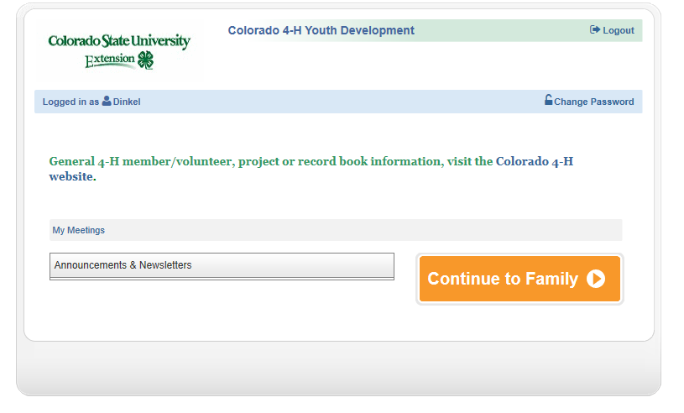



**COLORADO**

**4HONLINE**



***Want to become a Colorado 4-H Member?***   
Wonderful! Beginning November 15th you can re-enroll online or if a new family member enrolling, use the following website: co.4honline.com

Remember: Do not duplicate. Your family must use email from previous year if re-enrolling.  
**Join in on the Fun!**

Contact the Extension Office at 276-7390 if you need help getting set up through 4honline.



***New Paper Enrollment Will Begin***

***October 1, 2020***

**MC900340022[1]2020 - 2021 Enrollment Fees MC900340032[1]**

**Cloverbuds $25**

**Basic Enrollment $25**

**Additional Projects $ 6**

**Shooting Sports Range Fee $ 5**

**Horse Project Insurance Fee $ 1**

**Depending on the project, there may be additional costs associated with supplies you will need or fees that may be charged for project meeting classes. If credit card payment is added to 4-H Online registration the fee will be more than $25 due to processing fees. Payment can still be made at the office with cash or check.**

**New this year, families will purchase their own project manuals through the office. Book fees range from $3 - $30. Due to COVID affecting book availability from CSU, we may need to check various ordering sources to order your book this year and we will send you an invoice for any books ordered.**

**Be sure to keep your manuals from year to year.**



**4-H Achievement Awards Program**

What: 4-H Achievement Award Program

Date: Sunday, October 18

When: 2:00 – 4:00 PM

Where:  **Pathfinder Park**

You do great things! It’s time for recognition!

Please join us at our annual 4-H Achievement Awards Program. Come help us recognize our talented members & volunteers!

This year all of the Fair Awards (awards normally given out during Parade of Champions) will be given out during the Achievement program!

Colorado Leadership Camp

Unfortunately, Colorado Leadership Camp has been canceled for 2020, but we are looking forward to 2021!

----------------------------------------------------------------------------

**Attention Project Leaders!**

**You will be receiving a short survey via e-mail asking you if you plan to continue as a project leader and how you would like to help as a leader (through face to face project classes, online help, running a facebook group, etc.). Please fill out the survey by September 15th.**

**Thank you for all you do!**

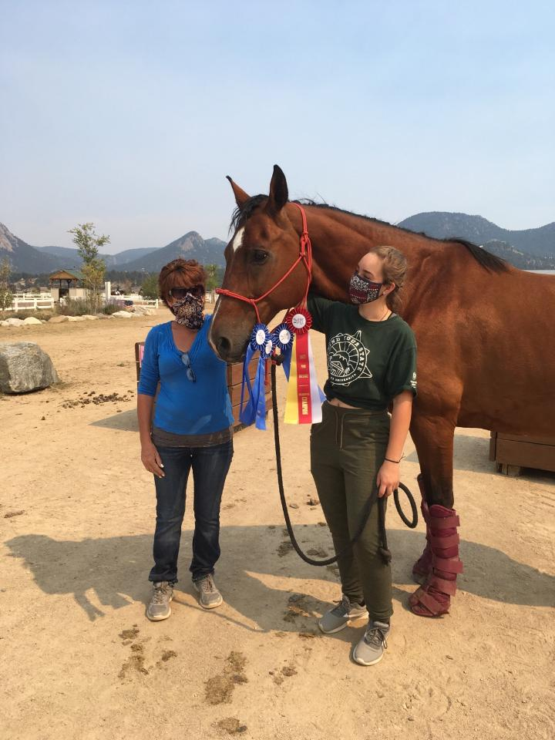

**Congratulations to Emily Schmid for receiving a USDF bronze medal!**

**The weekend of 8/14/2020, she rode 3 level test 3 at Estes Park and received scores of 64.6245, 66.750, and 67.250.   There are only approximately 20 youth in the United States that receive this award every year. Emily is the 1st youth to exclusively train in Fremont County and receive this award.  This young lady started off riding English in 4-H horse shows and now has become an accomplished dressage rider.**



Interested in growing plants from seeds? Go to <https://extension.colostate.edu/topic-areas/yard-garden/growing-plants-from-seed-7-409/> and find out how!!

Did you know that the Japanese Beetle larvae is a type of white grub that feeds on the roots of your grass? If you want to learn more go to: <https://extension.colostate.edu/topic-areas/insects/japanese-beetle-5-601/>

Colorado State University, U. S. Department of Agriculture and Colorado counties cooperating. Extension programs are available to

all without discrimination.