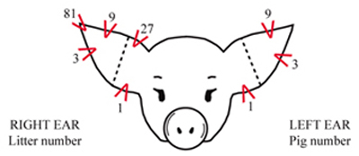
Above is a guide to help you through ear notch practice for the swine market tests. The litter number markings are how many litters an individual farm has in a farrowing season. This can vary per farm. For example, one farm may have 13 sows, and another may have over 100, so these notches are to indicate which litter the pigs came from on an individual farm. The pig number has less options for numbers because typically sows do not have more than 14 pigs in a litter. Therefore, a 27 or 81 notch would not be necessary. In each quadrant on the ear (besides notch 81 in litter number) there can be two notches in each section. For example, for litter number, there can be two notches in the section for 1’s, two notches in the section for 3’s, 9’s, and 27’s. For pig number, there can be two notches in each section as well. Every farm notches pigs differently. This picture above is typically how pigs are marked.

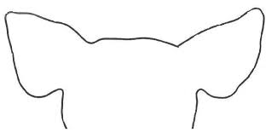

5-3 28-2

36-11 8-7

26-9 87-13

91-8 63-5

54-2 13-7

37-10 41-4

